

**LAB ASSIGMENT #1**

|  |  |
| --- | --- |
| **SUBMITTED BY** | **S.M.SHAHEER ALI SHAH** |
| **SUBMITTED TO** | **MAM ANIQA** |
| **REGISTRATION NO.** | **FA20-BCS-079(3C)** |
| **SUBJECT** | **DLD** |
| **DEPARTMENT** | **COMPUTER SCIENCE** |
| **DATE** | **16-09-2021** |

***LAB TASK***

**TASK 1:** Name the Basic Toolboxes of EWB



**Answer:**

1. Favorite 8. Digital

2. Source 9. Indicators

3. Basic 10. Controls

4. Diode 11. Miscellaneous

5. Transistor 12. Instruments

6. Analog, Mixed, Digital Ic's

7. Logic Gates

**TASK 2:** Familiarize with Basic Buttons in EWB Toolboxes

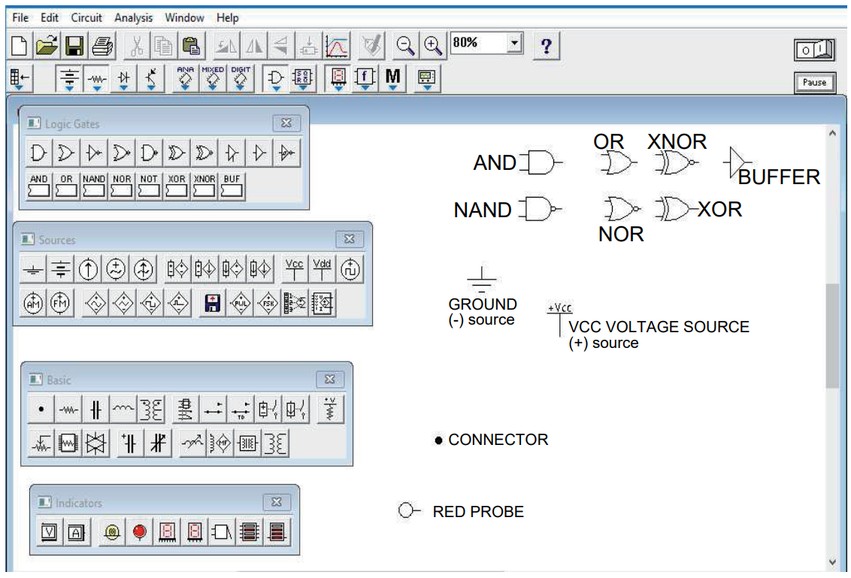

**TASK 3:** Draw the following Circuit

􀁸 Connect the Ground to the input of the Inverter.

􀁸 Connect the output of the Inverter to the input of the Red Probe.

􀁸 Start Simulation.

􀁸 State your observations down.

**Observations:**

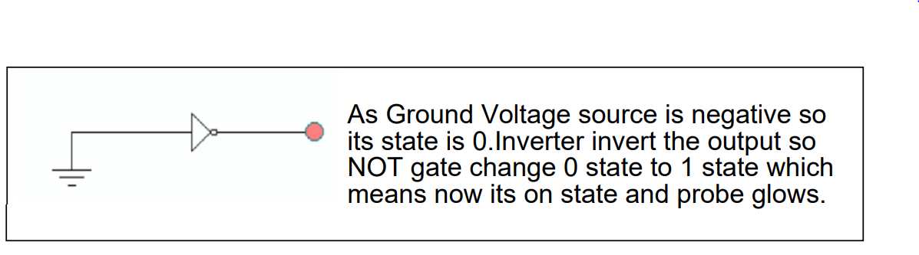

Stop the simulation and connect **+Vcc Voltage Source** instead of Ground to

the input of the Red Probe. Start simulation and state your observations.

**Observations:**

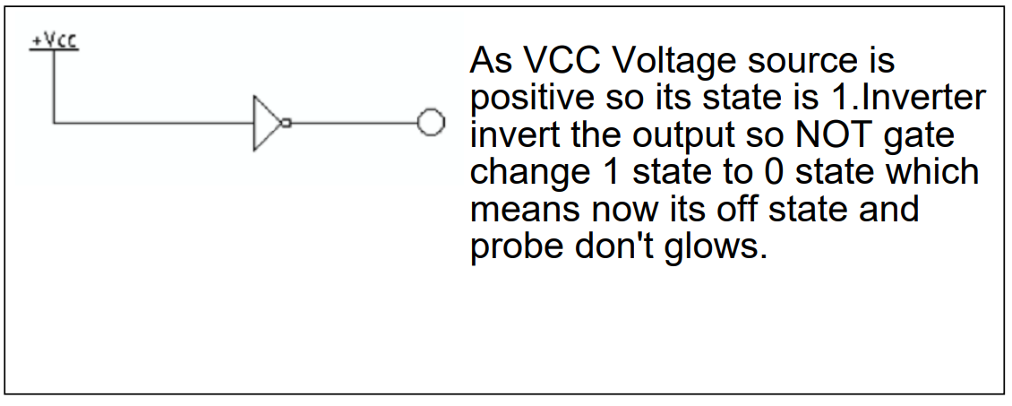

**TASK 4:** Name the following Icons and state down their functions.

